**SETUP ENVIRONMENT:**

**CREATE AWS ACCOUNT:**

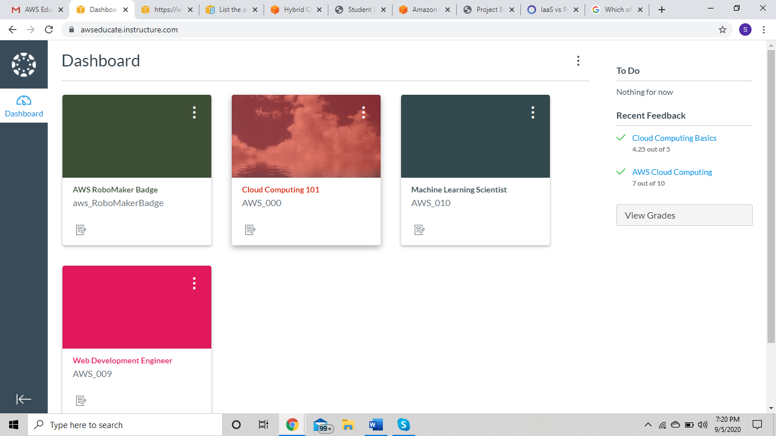

**INSTALL NODE RED :**

Step by step process to install the Node_red locally:

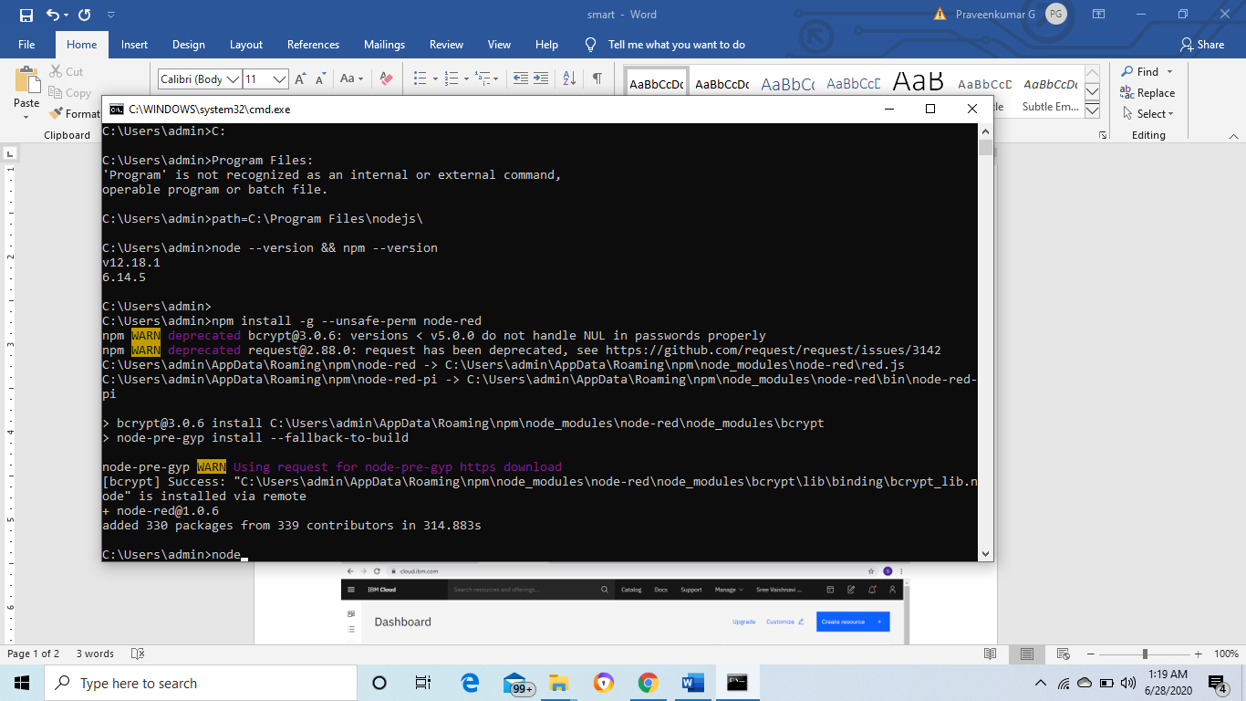

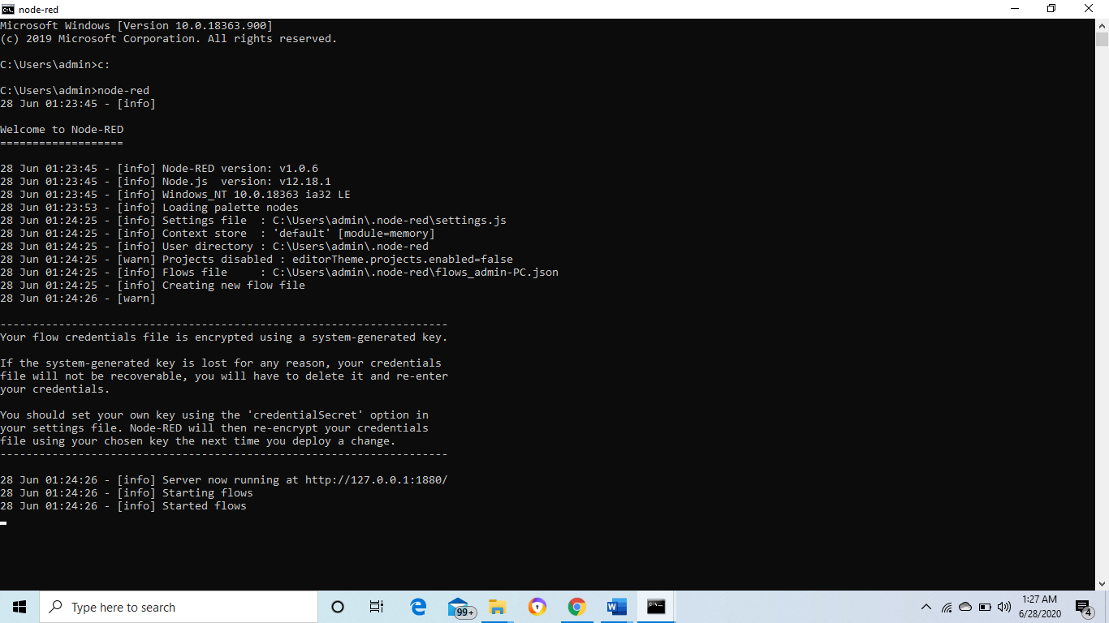

http://127.0.0.1:1880/

